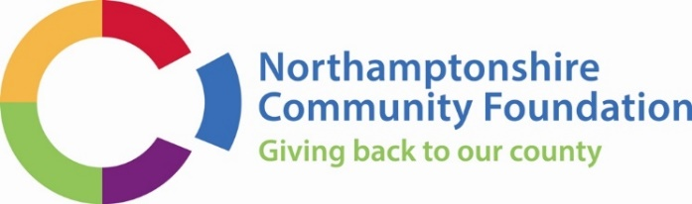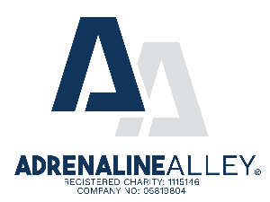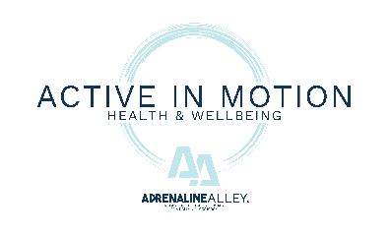

John Chard-Young Legacy Fund Guidance for applicants

We welcome you to our Guidance on applying for a grant. The following information is intended to give you a step-by-step approach to help you make the best of your application.

Please let us know if you need assistance in completing an application, for example if English is not your first language.

We strongly recommend the Foundation’s grants team looks at your application form before you submit the final version.

Please also let us know if you have problems accessing a computer or using one and we will direct you to a support agency to help you do this.

It is important that you read all the Guidance, especially in regards to the type of support are applying for. Applications will be assessed throughout the year.

What is the John Chard-Young Legacy Fund?

The John Chard-Young Legacy Fund is a bursary scheme providing Adrenaline Alley sporting and Active In Motion (A.I.M) Health & Wellness Centre sessions to help improve the overall wellbeing of those in need. John Chard-Young was the co-founder and inspiration behind Adrenaline Alley, one of Europe’s largest indoor BMX and Skateboard Parks and safe space for those interested in urban sports.

Introduction

Northamptonshire Community Foundation is an independent grant-giving organisation that aims to improve the quality of life for people in our County by awarding grants to grassroots groups. All our grants are funded by direct donations to Northamptonshire Community Foundation or by the interest generated and any capital growth from our endowment funds. Individuals, families, companies, statutory agencies and other trusts set up these funds, which support a wide variety of causes and we match applications to grant programmes.

We recommend that you plan your application well in advance. It can be sent to us at any time. You only need to make one application. Please read these guidelines carefully, complete the application form and send it to us with the items listed at the end of the application form. If you have a bank account, please provide a recent copy of your bank statement. If you do not receive an acknowledgement, please contact us. You may receive a phone call from a member of our staff requesting further information. You will normally receive a decision within six weeks.

Our Commitment

We are committed to making our criteria understandable and accessible whilst supporting applicants to make the best application possible. We will ensure we are being transparent about our processes and, where possible, engaging local people and the fund holders in making the final decision. We will strive to make grants that are relevant to local need and have a direct impact on the community and supporting projects that help people to help themselves. We will ensure that all applications are treated fairly and undergo an assessment process. We will make sure that all grants given are measurable and that successful applicants are aware of our expectations and also supporting applicants in line with the donor’s expectations and criteria. We aim to assess all completed applications quickly and make them available for the next panel date.

Support sessions

The John Chard-Young Legacy Fund is able to provide three types of support to individuals and applicants can select the most appropriate option for them. Support available includes:

- Adrenaline Alley Sports sessions – these sessions will provide the opportunity to take part in urban sports including BMX, Skateboard, skate or scooter. This can be taken up as 12 sessions lasting up to four and a half hours or eight sessions at 9 hours per day when the facility is open. The sessions must be used within a twelve-month period.
- A.I.M Health & Wellness Centre sessions – these sessions can include access to the wellbeing suite where you are able to use exercise machines that are low impact and power assisted, under the guidance of instructors. This can be taken up as 12 sessions and must be used within a six-month period. Or, in partnership with Rockingham Forest Wellbeing, you can access holistic therapies such as osteopathy, sports massage, acupuncture and injury rehabilitation.
Step 1: All about John Chard-Young Legacy Fund

Who can apply?

- You must be living in Northamptonshire – people living with a disability and reside outside of Northamptonshire are also eligible to apply
- You must be able to evidence that you are struggling to pay for costs that will support your mental and/or physical health and wellbeing*
- You must be aged 16 years old or older to apply for the wellbeing sessions
- You must be 12 years old or older to apply for the sports session taking place at Adrenaline Alley
- You must be an existing member of Adrenaline Alley or A.I.M

*As part of this, we ask applicants to provide proof of financial hardship, such as evidence of a means-tested benefit (e.g. Universal Credit, income-related ESA, Housing Benefit) or a recent bank statement that includes incoming payments of means-tested benefit. Please note that Personal Independence Payment (PIP) or Disability Living Allowance (DLA) alone do not demonstrate financial hardship, as these benefits are not means-tested

Exclusions:
The fund will not support the following:
- Those unable to evidence financial and social barriers to accessing support your mental and/or physical health and wellbeing
- If you are or have been a professional athlete, you will not be able to apply for Adrenaline Alley sports sessions
Can I apply more than once?

At this current time, the John Chard-Young Legacy Fund will support an individual once per year. Extensions may be provided at the recommendation of the support session provider and will be at the discretion of the fund-holder. Applicants can only apply for one type of support sessions at a time.

How do I apply?

The Community Foundation will accept applications throughout the year.

Advice on filling in the application form:

- Ensure each question is answered fully.
- If you are assisting someone to complete this application, please ensure that the applicant has attempted sections of the application themselves as this allows their voice to be heard.
- Remember to let us know what type of support you are looking to access and how you believe that will support your mental and/or physical wellbeing.
- If you have a bank account, please provide a copy of your recent bank statement along with your application.

Step 2: Guide to applying

Contact Northamptonshire Community Foundation to discuss your application on
01604 230033. You will then need to complete an online application form for the appropriate support session you wish to access. Go to the Grants Section on our website - http://www.ncf.uk.com.

Once you start the online application process, you can save the application form by pressing “save my progress and resume later” and creating a password. You can return to the form at a later time to make changes if you so wish.

We strongly recommend our grants team looks at your application form before you submit the final version. To do this you will need to get in touch with the Grants Team by emailing enquiries@ncf.uk.com

A member of the Grants Team will then reply to your email with feedback and suggestions for changes, if necessary. At this stage you can submit your final application form online by pressing the ‘Submit’ button on the last page. Please note, if there are any errors the form will not be processed and will return to the first page – asking you to complete any boxes you have left blank. You will need to submit any supporting documents at this time.

Your application will then be processed, assessed and considered by the Grants Team. We will let you know if your application has been successful or not by email.

If successful, applicants will be sent a bursary agreement to sign and send back.

Successful applicants will then be contacted by the Wellbeing Manager for Adrenaline Alley and A.I.M to support their access to their chosen health and wellbeing sessions.

Step 3: When to Apply

Applications are considered throughout the year.

Step 4: How long is the support for?

Depending on the type of support you are looking to access, you will have 6-12 months to complete the allocation of sessions you have been awarded - unless an extension has been approved at the discretion of the fund-holder.

18 Albion Place,
Northampton
NN1 1UD
Telephone 01604 230033
Tel: 01604 230033
Email: enquiries@ncf.uk.com
Website: www.ncf.uk.com



