How to take the best photograph
Here at Northamptonshire Community Foundation we like to promote and celebrate the projects that we support, we do this in a variety of ways including through photos of your project in action.
Here is a quick checklist of what you need to do to create the perfect photograph.
First here is an example of bad photos and good photos taken in our offices:
Using the correct subject
x

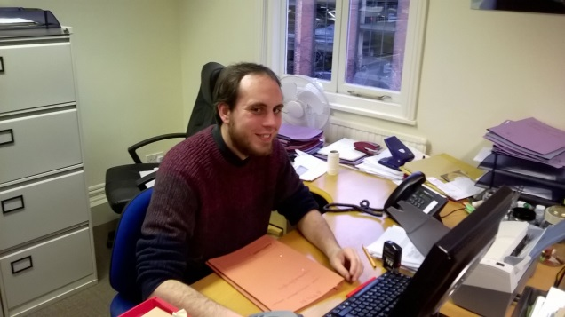
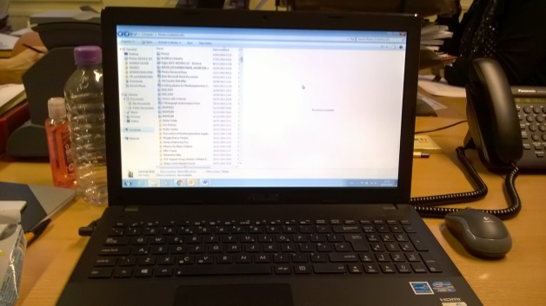

This photo does represent the foundation as Anthony, our Grants Team Assistant is in the picture and therefore it brings personality to the image.
This photo does not represent the foundation and what we do. It could be a photo of a computer taken in any office it does not show our identity.

x

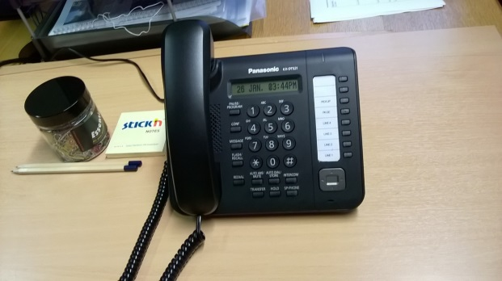
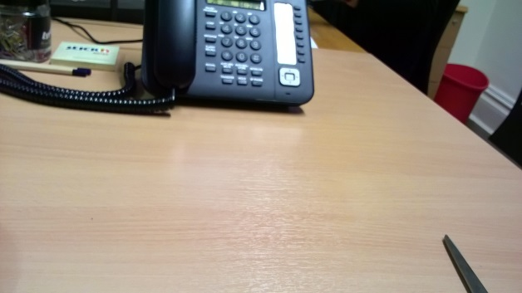
Blurriness and framing

This photo is clear and has the phone in the centre of the image. Ensure that you frame your shots correctly to prevent chopping off parts of the image.
This photo is blurry and the phone, which is the main object the image, has been chopped off at the top.

Contrast
x

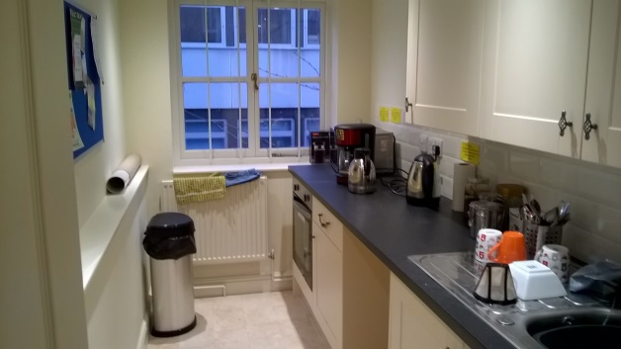
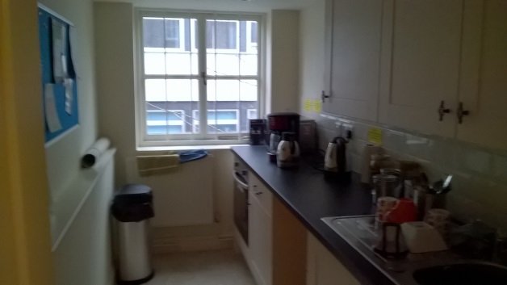
This photo is too dark and is difficult to view the entire room.
The contrast in this photo is better as it is lighter and it produces a clearer image.

Checklist for producing a great photograph
- Ensure the lighting conditions are not too bright or dark that it will affect the outcome of the photo
Tip: If you are taking a photo and there is light shining affecting the image, then turn your back on the direction of the light as this will prevent the light shining into lens
- Make sure you frame your shot correctly and be sure not to cut off part of the image when taking the photo
Tip: When taking a photo choose a focus point of an object or person and centre that in the middle
- When taking photos make sure it is relevant and represents the project
Tip: Photograph sessions in action and be sure to photograph the people involved to highlight how your project is helping the community
- Where possible include people in the photo even if we have funded equipment , as a foundation that supports the community it is important to show how these projects are benefiting the people of Northamptonshire
Uploading pictures
- View your photos first before sending them over to us
- Make sure there are no photos that are blurry, out of focus or have bad lighting conditions
- Delete any duplicate photos
- Ensure the file size is not too large and save your file as a jpeg or png
Please send photographs to Lucy Davies, Communications and Grants Officer at lucy@ncf.uk.com
If you have any questions please call 01604 230033
Please note we no longer accept photographs through the post.

