Application Guide: How will your activity address priority needs identified in the Hidden Needs Report
Northamptonshire Community Foundation is prioritising applications across certain programmes which can evidence they will address one or more of the priority needs identified in the Hidden Needs Report.
You can read the summary report and view the presentation here: http://www.ncf.uk.com/about-us/hiddenneeds
In the online application you will be expected to address this in the following question in section 3 on impact on the form and part of the question requests how you will tackle one or more of the priority needs highlighted in our Hidden Needs Report:
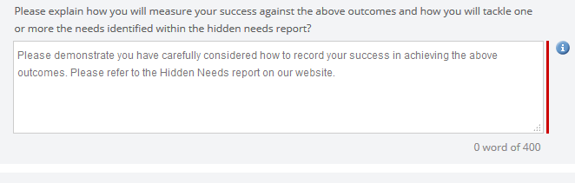
An example hidden need identified in the report is child poverty so you may wish to show how your project activity will tackle this need.
You may therefore wish to do and think about the following when answering this question on the form:
- Read the Hidden Needs Summary Report
- Who are the beneficiaries of your project and where is it taking place
- What need(s) are you addressing that reflect one or more priority needs in the report
- How the activities or event taking place will help tackle or address a hidden need
If your project was tackling child poverty you may wish to state that you are going to tackle child poverty in Northampton working with children and young people living in a particular ward area of the county where you are targeting low income families. The activity you are putting on provides support to children and their families which will relieve the issue of for example living on a low income e.g. you are a breakfast club working in a specific area targeting families living on a low income. The breakfast club will help alleviate poverty and provide opportunities for families to receive additional support on issues they are facing which may help relieve financial stress.
There are no right or wrong answers and the above is just an example of how you may wish to think about answering this part of the question. If you have any further questions or would like to discuss this further then please contact the Grants Team on 01604 230033 and we will be happy to provide advice and support.

